Activity Sign-Up Sheet Instructions and Notes

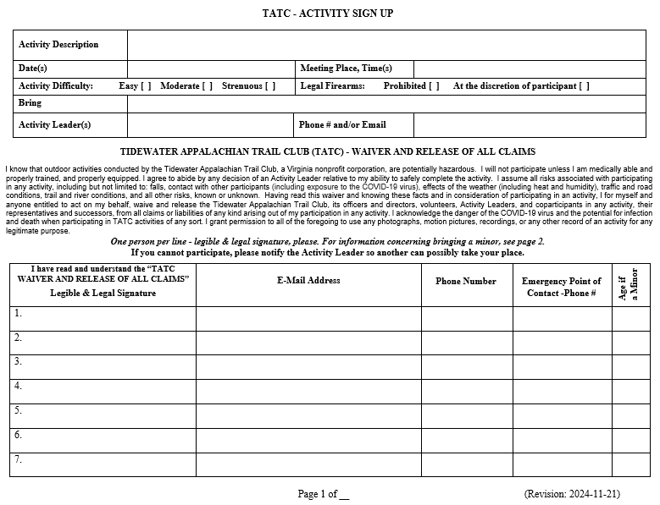

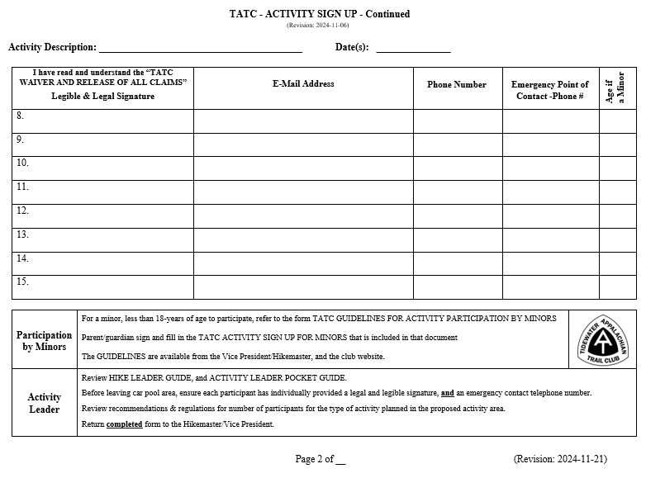

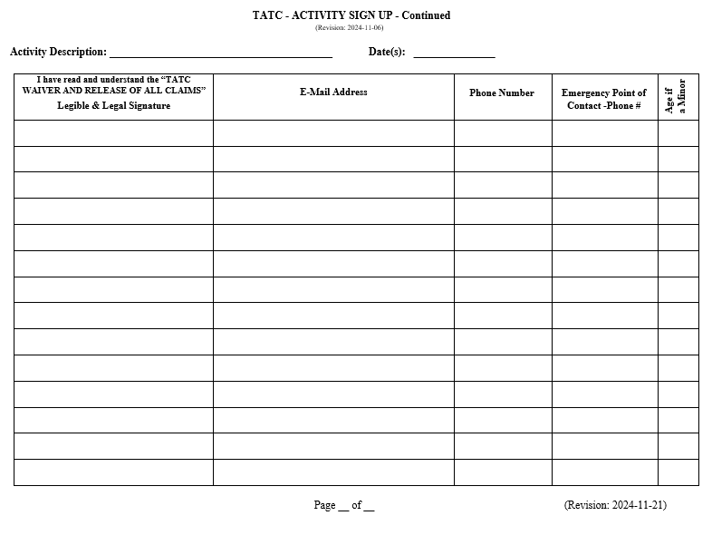

A copy of the TATC Activity Sign-Up Sheet is included as the first three pages of this instruction. Copies are also available from the Vice President/Hike Master at General Membership Meetings or off of our website at https://www.tidewateratc.com/Activity-Sign-Up-Form
Instructions for Filling in the Blanks for an Activity
Block | Include:
Activity Description | Destination and type of event, as well as other information such as parking, fees, ride-sharing, reservations, cut-off dates, etc.
Date(s) | Date or range of dates
Meeting Place, Time(s): | Location of meeting place and meeting time for one-day events  or Location of meeting place, date, and meeting time for multi-day events
Activity Difficulty: Easy [ ] Moderate [ ] Strenuous [ ] | Check one
Legal Firearms: Prohibited [ ] At the discretion of participant [ ] | Check one or none
Bring | What gear to bring, such as appropriate clothing, footwear, water, water bottle, water filter, food, pack, Tent, Hat or Cap, Sleeping Bag, Sleeping Pad, Hiking Poles, Flashlight, Snowshoes, Crampons, Lighter, PFDs, Canoe or Kayak, Bicycle, First Aid Kit, Insecticide, Sunscreen, Cooking Gear, Stove, Safety Gear. Toiletries, Paper, Pen, etc.
Activity Leader(s) | Activity Leader’s Name or Names of Activity Co-Leaders
Phone # and/or Email | Phone # and or Email Address for Activity Leader or Co-Leaders
Legible and Legal Signature | Provide a “legible and legal” signature, it can be printed. By signing, you are acknowledging that you have “read and understand” the "Tidewater Appalachian Trail Club (TATC) Waiver and Release of all Claims" printed on the TATC ACTIVITY SIGN UP sheet. If you signed up online, please make sure to provide your legal signature on the sign-up sheet when you meet for the trip. Signing up for an event is normally accomplished by contacting the Activity Leader(s), by filling in the ACTIVITY SIGN UPs at the monthly TATC General Membership Meeting, by signing up for an event on Meetup when listed, or by emailing or phoning the Activity Leader(s). Sign-ups for Tuesday Group events can be made online using the Tuesday Group’s website.
Email Address | Email address of the participant, please ensure it is legible
Phone Number | Phone Number of the participant, please ensure it is legible, please include Area Codes
Emergency Point of Contact - Phone # | Name and Phone Number of the participant’s Emergency Point of Contact (POC)
Age if a Minor | Age(s) of any sponsored minors. Anyone participating in a TATC activity less than 18-years of age must be accompanied by a parent or guardian. The parent or guardian needs to read and adhere to the GUIDELINES FOR ACTIVITY PARTICIPATION BY MINORS located at: https://www.tidewateratc.com/resources/Education/Guidelines%20for%20Participation%20by%20Minors.pdf

Sample of the Header Information for an Activity Sign-Up Sheet
Activity Description | Backpacking Trip in Dolly Sods Wilderness, WV, hike 20-miles, three days, two nights, share a ride
Date(s) | Friday – Sunday, May 17-19, 2025 | Meeting Place, Time(s) | Ocean View Shopping Center, 111 W Ocean View  Norfolk, VA - Friday, May 17, 2024, 7:00 AM
Activity Difficulty: Easy [ ] Moderate [x ] Strenuous [ ] |  | Legal Firearms: Prohibited [ ] At the discretion of participant [x]
Bring | Suitable Clothing, Backpacking Gear, and Food for Three Days.
Activity Leader(s) | Chuck E. Cheese | Phone # and/or Email | 757-867-5309, chuckecheese789@gmail.com

An ACTIVITY SIGN UP performs many functions:
- It allows you to sign up for a particular activity.
- It shows the Activity Leader how many want to participate and/or to limit participation by limiting the number of slots available.
- The data at the top of the sheet includes meeting time and place, and other nice or need-to-know information.
- By providing names and telephone numbers, the ACTIVITY SIGN UP allows the Activity Leader to inform participants when there is a cancellation or change of plans.
- It provides emergency contact information to the Activity Leader.
- It helps us report trail maintenance hours to the ATC, USFS and NPS
- It is used to report volunteer hours to the TATC Timekeeper to help determine ATC and TATC awards earned.

Please do not wait until the last moment to add your name to the list. You may be too late, especially if the number of slot available for an activity are limited. If you find you cannot participate in an activity you signed up for, please let the Activity Leader know as soon as possible so that someone else can go in your place. Sign up early to allow the leader:
• To make plans.
• To coordinate car-pooling.
• To communicate with you the participant.
• To arrange for and receive any necessary permits.
• To collect and remit fees or deposits, if required.
• To make the number of copies required for a seminar or training session.

Please contact the TATC Hikemaster at hikemaster@tidewateratc.com if you have any questions.

